SAP Integration Functional Specification

Project Identification
Project Name | Customer Name
S/4 Integration | MOHAWK

Revision History
Version | Date | Author | Derivation/Comments
1.0 | 07/22/2024 | Amit Jadhav  Harish Korrapati

Review History
Version | Date | Reviewer | Remarks
1.0 |  | Shamala Thimmaraju  Nadim Iqbal

Approval / Sign-Off History
Version | Date | Approver | Remarks

<Those sections in this document which are not applicable for the development should be left blank>

Table of Contents
2 Business Overview 3
1.1 Business process detail 3
1.1.1 Current functionality 3
1.1.2 Desired functionality 4
1.1.3 Category of Change 4
1.1.4 Dependencies / Constraints 4
1.1.5 Business Case 4
2 Interface Overview 5
2.1 Interface flow diagram 5
2.2 Detailed description of interfaces 6
2.3 Mapping Details 7
3 Involved Systems 8
3.1 Application 8
3.2 Security and Authorization 8
3.3 Message Format 8
3.4 Sample data 8
3.5 File Naming Convention 8
3.6 Routing Rules 8
4 Error Handling, Monitoring and Alerting Requirements 9
5 Archiving Strategy 9

Business Overview

MOHAWK​ solutions company is an AdvanSix customer which integrates with A6 SAP system to send Invoice and receive order acknowledgment, ASN and commercial invoices electronically.

Business process detail
Existing Interfaces:
- Invoice – Inbound

Current functionality

Invoice
Finally, an invoice output is sent to MOHAWK automatically when billing document in A6 SAP S4HANA is released to accounting. SAP sends the message feed to CPI by consuming an API provided by CPI.

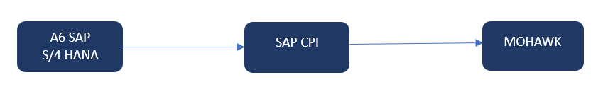

Desired functionality

Invoice: We can send this output in the same way as the existing design for Invoice Output. We can use B2B standard SOAP API.

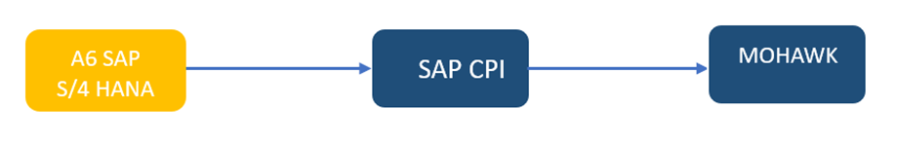

Category of Change

New Business Process | Enhancement | Bug (Product / Customization)
Productivity Improvement | Performance Improvement | Interface with Local System
Others (Please indicate details):

Dependencies / Constraints
Below must be completed for testing purpose:
- Basic sales configuration
- Customer master data setup
- Material master setup
- Output type config

Business Case
<Describe the business case and justification for the same in detail>

Interface Overview
<Fill the table given below to capture the details for all the interfaces involved in the business process.>
Sl No | Interface Id | Interface Description | Source | Target | Interface Mode | Processing Type | Frequency | Complexity
1 | Invoice | Invoice Integration from S/4 to MOHAWK | S/4 | MOHAWK​ | Async | Real time | NA | Medium

Interface flow diagram

Invoice – Inbound Flow from AdvanSix to MOHAWK

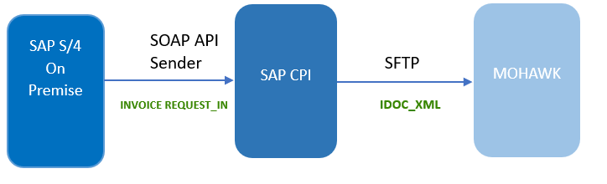

Detailed description of interfaces
Invoice- Inbound Flow from AdvanSix to MOHAWK
- After order confirmation, Advansix team will process the manual delivery and do the picking packing loading and then do the post goods issue. After the delivery processed, AdvanSix team will create Invoice manually.
- After the invoice is documented, invoice output type RD00 will be created to generated SOAP API INVOICEREQUEST_IN.
- As soon as the delivery block is released, RD00 output type will be created to generate SOAP API INVOICEREQUEST_IN.
- CPI converts the SOAP API XML to IDOC XML using mapping program & groovy script transformation.
- IDOC XML is sent from CPI to MOHAWK.
- CPI will send Invoice creation status to user mail group as acknowledgement in case of Successful creation.
- CPI will send failure intimation with error details (Mapping Error or IDOC XML data validation Error or Exception handling) to user group mail in case of any failure.
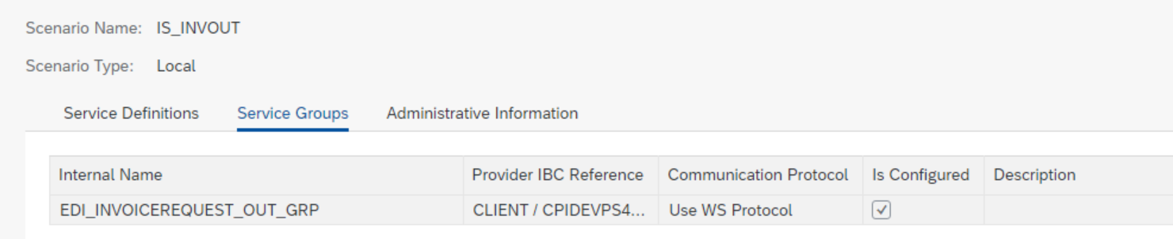
URL: https://deveconnect.it-cpi009-rt.cfapps.us20.hana.ondemand.com:443/cxf/CUSTOMERINVOICE_CPIDEV

Also fill the table below to specify the business process and sub process to which interface belongs.>
S No | Interface Id | Business Area | Business Process | Sub Process
1 | Invoice | Order to Cash (OTC) | Billing | Invoice/AP

Mapping Details
<Provide mapping sheet with source and target fields and logics>

Involved Systems
<Provide the details of the systems involved in the business process>

Application
<Details of the application/system. Copy this table for all the involved applications>
Application | MOHAWK
Application version | NA
<Provide all details related to connection> | Development | Test | Production
 | ft.tungsten-network.com
Application Access | SFTP

Application | SAP S/4 HANA On-Premise
Application version | 2021
<Provide all details related to connection> | Development | Test | Production
 | S4D | S4Q | S4P
Application Access | SOAP API

Security and Authorization
S4 HANA to CPI – RFC destination with credentials and SSL certificates installed in strust

Message Format
IDOC XML – MOHAWK​
SOAP API XML – SAP S/4 HANA On-Premise

Sample data

File Naming Convention
NA

Routing Rules
NA

Error Handling, Monitoring and Alerting Requirements
- Exception Subprocess used in CPI for error handling.
- CPI will send failure intimation with error details (Mapping Error or IDOC XML data validation Error) to user group mail in case of any failure.
- Resending messages will be taken care of at the source system.
- Reprocessing also can be done in S4H AIF.
- S4H will send failure intimation with error details (Exception handling) to user group mail in case of any failure

Archiving Strategy
- Invoice IDOC XML is archived in MOHAWK.
- SOAP API data is available in S/4 AIF
- The messages before and after mapping are archived in SAP CPI for 7 days.

